**Task No. 1: Take any integer as input, if the number is greater than 5 print it**

**If a>5, print a**

**Else if a=0,then Halt**

**Else if a<5,then halt**

**Solution:**

in

sto 95

lda 95

sub 96

brz 06

brp 07

hlt

lda 95

out

hlt

*96

dat 005

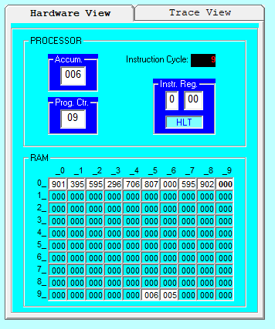**Output:**

**Task No. 2: Take two input from user and print the largest number.**

**Solution:**

in

sto 95

in

sto 96

lda 95

sub 96

brp 10

lda 96

out 96

hlt

lda 95

out 95

hlt

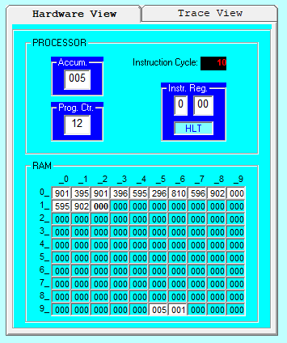**Output:**

**Task No. 3: Write pseudocode for the following code:**

**Solution:**

in

sto 90

in

sto 91

sub 90

brz 07

brp 10

lda 90

add 91

out

hlt

lda 91

sub 90

out

hlt

**Output:**

Input A

Input B

Subtract B-A

If (branch ==0)

{

Load A

Add A+B

Output the Result & terminate

}

Else if (branch==positive number)

{

Load B

Subract B-A

Output the Result & terminate

}

**Task No. 4: Take two inputs and print the first non-zero number.**

**Solution:**

in

sto 95

in

sto 96

lda 95

brz 09

lda 95

out

hlt

lda 96

out

hlt

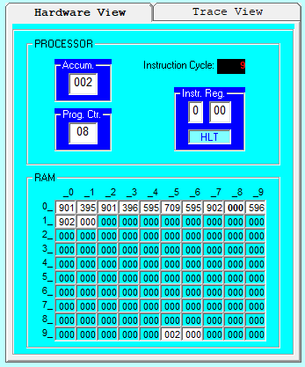**Output:**

**Task No. 5: Take two inputs and subtract them if a≠0 else add them.**

**Solution:**

in

sto 95

in

sto 96

lda 95

brz 09

sub 96

out

hlt

lda 95

add 96

out

hlt

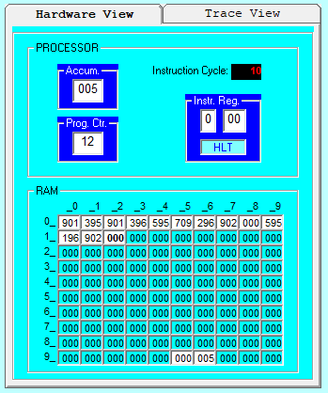**Output:**

